H.T No
Regulations:
A15


Sreenidhi Institute of Science and Technology
(An Autonomous Institution)
Code No: 5AC07 Date: 01-Dec-2018 (AN)

B.Tech II-Year II-Semester External Examination, Nov/Dec - 2018 (Supplementary)
Control Systems (EEE)

Time: 3 Hours Max.Marks:75

Note: a) No additional answer sheets will be provided.
b) All sub-parts of a question must be answered at one place only, otherwise it will not be valued.
c) Missing data can be assumed suitably.

Part - A Max.Marks:25

Answer all QUESTIONS.

1. | Define transfer function and give two limitations of it. | [3M]
2. | Specify the effects of proportional derivative controller. | [3M]
3. | State Routh Stability criterion. | [3M]
4. | What is frequency response analysis? | [3M]
5. | Explain the stability in polar plot point of view. | [3M]
6. | Write the properties of state transition matrix. | [2M]
7. | Explain Mason’s gain formula. | [2M]
8. | Define Phase margin and give its formula. | [2M]
9. | Draw the Lead compensator diagram. | [2M]
10. | What is Impulse response? | [2M]
Part – B Max.Marks:50
ANSWER ANY FIVE QUESTIONS. EACH QUESTION CARRIES 10 MARKS.

11. | a) | Draw the signal flow graph of the block diagram shown in Figure.1 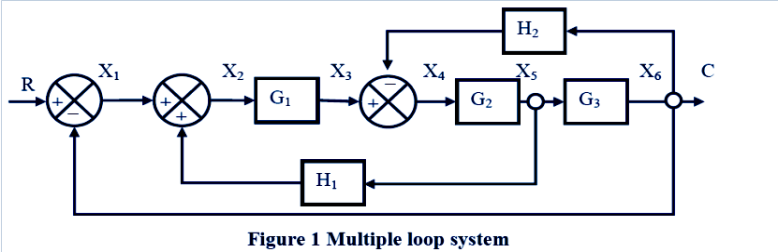 | [5M]
 | b) | Find the transfer function of Figure.1 using masons gain formula. | [5M]
12. |  | Find the rise time t_{r}, peak time t_{p}, max overshoot M_{p} and settling time t_{s} When the system is subject to a unit step i/p., for the 2nd order control system, where ξ = 0.6 & ω_{n}=5rad / sec, | [10M]
13. |  | Sketch the root locus for the given unity feedback system shown in below figure?  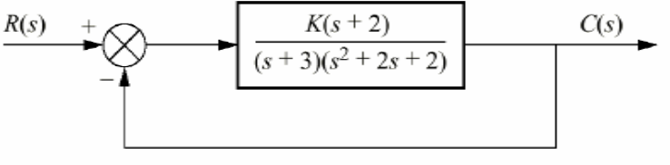 | [10M]
14. |  | Draw the bode magnitude and phase angle plot for the below loop transfer function. Also find the gain margin and phase margin.  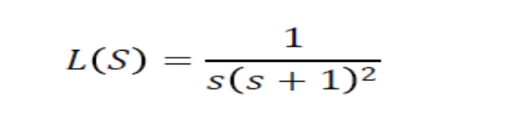 | [10M]
15. | a) | Explain the procedure for drawing the Nyquist plot? | [5M]
 | b) | Explain different compensation techniques? | [5M]
16. |  | Find the state transition matrix for the system given by  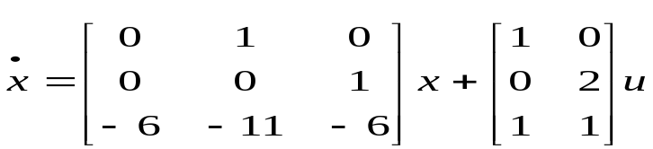 | [10M]
17. | a) | Differentiate between open loop and closed loop control systems? | [3M]
 | b) | What are different test signals? | [3M]
 | c) | Explain the limitations of R-H criterion? | [4M]
18. | a) | Explain the effect of transportation delay on bode plots? | [3M]
 | b) | Analyze the stability using polar plots with suitable example? | [3M]
 | c) | Explain the diagonalization with suitable matrix? | [4M]

-- 00 -- 00 –

